**MINOR-1 PROJECT**

**END Term Report**

**Automobile Lodging Administration**

Submitted By:

|  |  |  |
| --- | --- | --- |
| **Name** | **Roll No** | **Branch** |
| Akansh Verma | R110219006 | CCVT |
| Amresh Garg | R110219009 | CCVT |
| Aviral Mehra | R110219031 | CCVT |
| Ayush Kanwar | R110219032 | CCVT |

**Under the Guidance of:**

Mr. Amrendra Nath Tripathi

**Department of Systemics**

**Synopsis Report on Automobile Lodging Administration (2021-22)**

**Project Title**

AUTOMOBILE LODGING ADMINISTRATION

# Abstract

The number of individuals owning a vehicle is increasing day by day, which results in the traffic that you see on the road. One of the main reasons for the traffic is the individuals looking for a parking spot. The current infrastructure regarding the parking facility is not enough to deal with all the vehicles on the road. To tackle this problem, we need a smart and efficient parking system that will help individuals locate and secure parking spaces at their convenience.

The smart parking system provides you with additional functionalities such as automated payments and various kinds of sensors to make your parking experience hassle-free.

**Introduction**

The parking system is an essential part of our day-to-day lives. Every year, the number of people who own a vehicle increases exponentially, resulting in increased pollution, frustration and stress for the driver, and a detriment to a high-quality lifestyle. According to a report by Ward intelligence, the global vehicle population stood at 1.32 billion cars and trucks by the end of 2016. This number has doubled compared to 20 years ago. By 2035, it is expected that there will be almost 2 billion cars on the road, or even sooner [1]. In Asia, the situation is even worse as compared to the cities in the west because of the narrow roads.

Many solutions have been put into place to tackle this problem, but the problem seems to exist nonetheless. Due to the lack of available parking spaces, people park their cars on the sides of roads, leading to traffic congestion and parking in no-parking zones, which leads to challans. If we are not able to contain this problem, it will lead to greater consequences in the future. For an individual to locate a parking space is not an easy feat.

# To tackle this problem, the most optimal solution is to introduce smart parking systems. The task handled by the smart parking system is to help drivers locate a parking space. It accomplishes this with the help of mobile applications and sensors that collect real time and deliver it to drivers providing them with a hassle-free parking experience.

# Other advantages of the smart parking system include:

# Less consumption of fuel: The drivers don't have to roam looking for parking spaces, instead they are directed to vacant spots.

# Safety of the driver: The drivers are distracted while looking for a spot to park their car. If their concentration will be on the road there will be a significant decrease in accidents.

# Guarantee of space available for parking

# Save time

Current state of parking

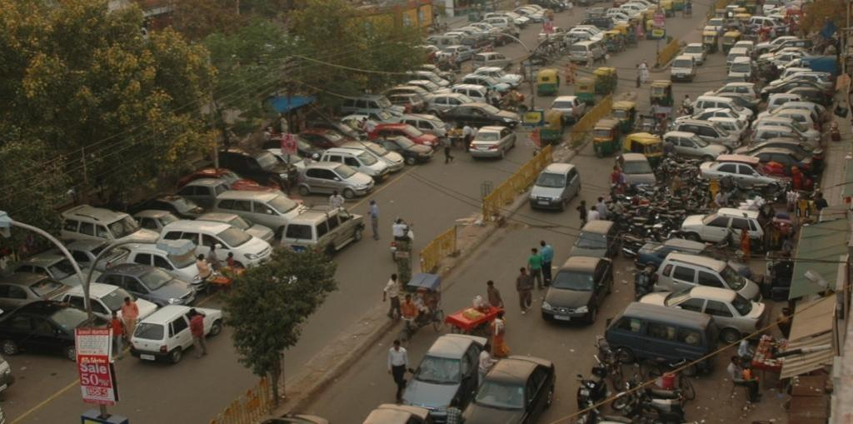

Figure [2]

After smart parking system

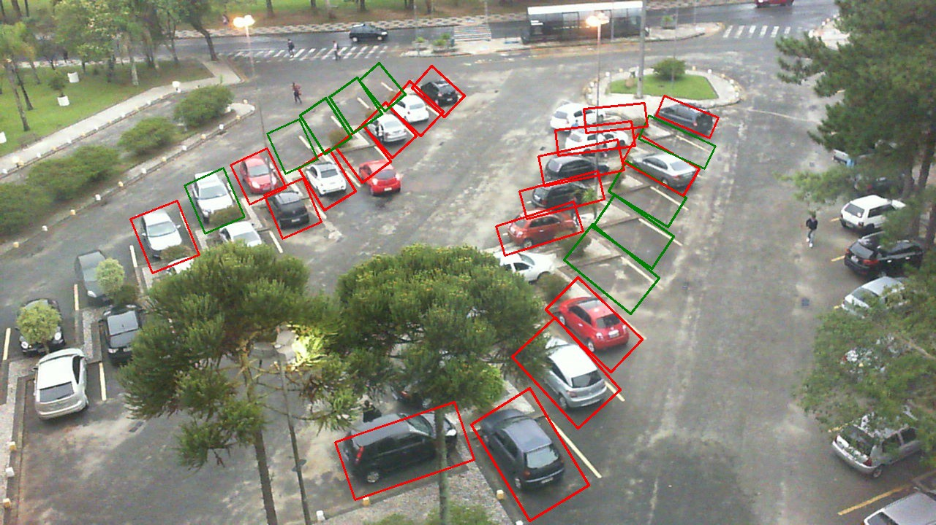

Figure [3]

# Literature Review

IoT and Cloud are one of the best approaches for a smart parking management system. So, we studied various research papers regarding smart parking management systems for our projects to know how to approach the problem and design the best possible solution.

· In the paper by Abhirup Khanna and Rishi Anand quote: Smart parking management system using IoT. They proposed an IOT based cloud-integrated smart parking system application to monitor and signal the users about the availability of parking space in the vicinity. The idea was to develop an application using cloud so that the users can get the information on real time basis. And by integrating Ultrasonic Sensors and Passive Infrared (PIR) sensors to determine if the parking slots are vacant or not.[4]

· In the paper by Eirini Eleni Tsiropoulou, John S.Baras, Symeon Papavassiliou & Surbhit Sinha quote: They adopted Radio Frequency Identification (RFID) in the implementation of smart parking management system to attain better energy efficiency and operational effectiveness. By demonstrating the significance of tag-to-tag communication in a passive RFID network against the traditional direct communication for expanding the user’s coverage area along with ensuring better connectivity among tags and increasing energy efficiency. [5]

# Problem Statement

# In today’s time, finding a parking space nearby is a tough task and especially if it is vacant or not is a serious task. As all the handling of these spaces is man-operated there is no data available as at what point of time how much space is available, or if it is available then there is no internal fragmentation. Also, if there is a clash between two users over a particular parking space then what solution can be provided to resolve this issue.

# Objectives

The main objective of our system is to manage the details of the routes, vehicles, parking slots, customers, and duration. The purpose of the application program is to reduce the manual overload of work and reduce manpower so as to efficiently and provide spaces to the customer at a much faster pace, which cannot be achieved unless there is huge manpower. We wanted to reduce the hassle in finding parking spaces and reduce the time of customers as our solution would provide all the details in a single go.

Sub-Objective:

* We use Dijkstra’s algorithm to provide the nearest parking slot. This algorithm works for both directed and undirected graphs.
* Using First Come First Serve we avoid the clash between two users who want to access the slot at same point of time. FCFS states that whichever process or in our case a vehicle arrives first at the parking slot will get to use the space first.

**Methodology**

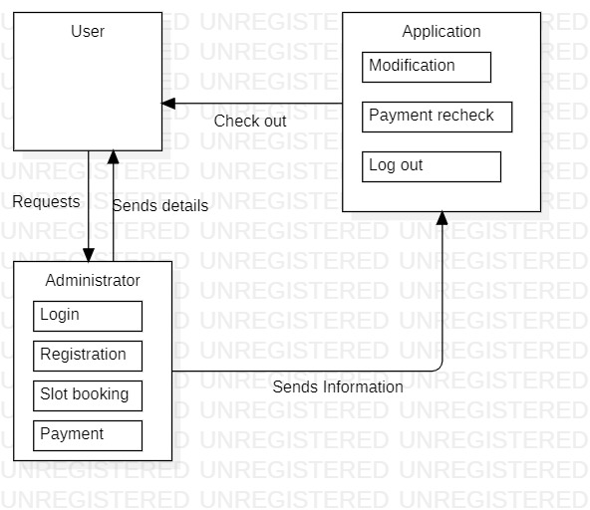

Our application consists of the following module: -

User Module-

This module of the application deals with the user experience overall. This module provides users with many functionalities including logging in to the system, creating a new id. Once the user is logged in the application, the user then can browse into multiple sections such as finding the nearest parking slot available, fetching distance to that destination, payment to book a slot there.

Administration Module-

This module is managed by the administrator who overlooks all the activities happening. Administrator role is to manage all the details of the user’s data registered with the application, the administrator also has to keep up with the allocation of the slots whether they are empty or full, and also the data regarding the updating of these slots are done by the administrator. The administrator also provides the booking option to the user.

Booking Module-

Once the slot is booked a notification is received by the user indicating allocated time, a system-generated number for verification purposes, an amount that can be paid either online or offline at the spot. Also, the user can cancel the slot by contacting with parking space before 30 minutes to get the refund.

# Experimental Setup

System requirements -

Windows: -

* Windows Vista SP2 or above
* Windows Server 2008 R2 SP1 (64-bit)
* Windows Server 2012 and 2012 R2 (64-bit)
* RAM: 128 MB
* Disk space: 124 MB for JRE; 2 MB for Java Update
* Processor: Minimum Pentium 2 266 MHz processor
* Windows 10 (8u51 and above)
* Windows 8.x (Desktop)

Linux: -

* Oracle Linux 5.5+
* Oracle Linux 6.x (32-bit), 6.x (64-bit)3
* Oracle Linux 7.x (64-bit)3 (7u67 and above)
* Red Hat Enterprise Linux 5.5+, 6.x (32-bit), 6.x (64-bit)3
* Red Hat Enterprise Linux 7.x (64-bit)3 (7u67 and above)
* Suse Linux Enterprise Server 10 SP2, 11.x
* Suse Linux Enterprise Server 12.x (7u75 and above)
* Ubuntu Linux 10.04 and above

# Data Flow Diagram

# 

**Use case**

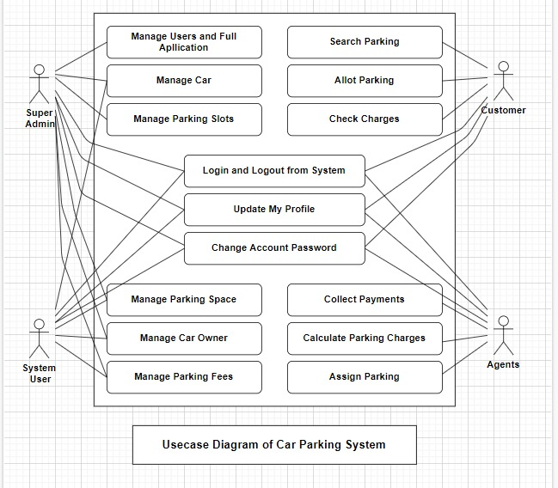

# References & GIT link

[1] https://www.parkeagle.com/2019/03/19/what-are-the-benefits-of-smart-parking-for-drivers/

[2]-https://cdn.downtoearth.org.in/library/large/2019-09-26/0.33164900_1569479209_anumita-.jpg

[3]-https://miro.medium.com/max/1400/1*y-OzDMnDxrcw_4KzgApFzA.jpeg

[4]- A. Khanna and R. Anand, "IoT based smart parking system," 2016 International Conference on Internet of Things and Applications (IOTA), 2016, pp. 266-270, doi: 10.1109/IOTA.2016.7562735.

[5]-Eirini Eleni Tsiropoulou, John S. Baras, Symeon Papavassiliou & Surbhit Sinha (2017) RFID-based smart parking management system, Cyber-Physical Systems, 3:1-4, 22-41, DOI: [10.1080/23335777.2017.1358765](https://doi.org/10.1080/23335777.2017.1358765)

[6]-Github- https://github.com/AkanshVerma/Project